**13. Design a system for home security systems, such that whenever someone approaches the gate, the LED starts blinking once every 100 ms.**

**Circuit Diagram:**

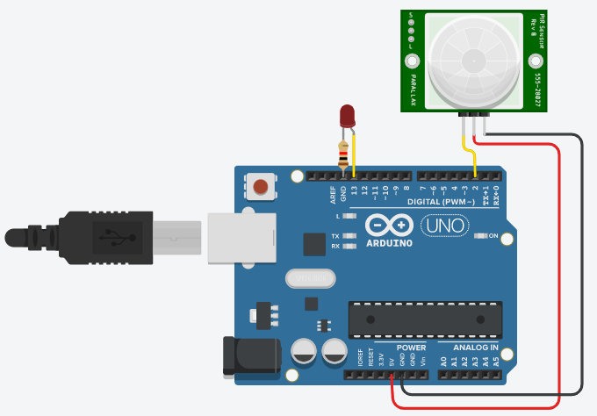

**Theory:**

The PIR (Passive Infrared Sensor) is used in this circuit to know if any human or animal is around or not. The led starts blinking. This can be used for safety in houses. We can also join buzzer with this for safety from burglars. This is very helpful when there is dark if we remove the delay time then it can glow the led by sensing any human or animal.

**Observation:**

When there is any human or any living organism which emit infrared light or radiation, then the led starts blinking.

**Problems & Troubleshooting:**

1.LED should be checked, sometimes it is broken.

2.Check the resistor of perfect value if it is greater than the led will not glow.

**Precautions:**

1.Connection wires should be continuous, there should not be any open circuit.

2.Selection of port in the arduino should be according to port in which arduino is connected.

**Learning Outcomes:**

1.Came to know how to use arduino circuits in daily used techs.

2.Came to know how the PIR sensor in arduinio.